SECTION 1: PRODUCT AND COMPANY IDENTIFICATION

PRODUCT NAME: Broiler Pak
PRODUCT CODES: CLE514363
Cas No: N/A

USE: Mixture used as an feed supplement; not for human consumption. Refer to SDS regarding safety, usage, applications, hazards, and disposal

MANUFACTURED FOR: Clear View Enterprises
ADDRESS: 451 Agnes Dr.,
Tontitown, AR 72770

MANUFACTURED BY: Catalyst
ADDRESS: 10100 Douglas Ave.
Urbandale, IA 80322

CLEAR VIEW PHONE: 866-361-4689
CATALYST PHONE: 515-254-1290
CHEMTREC PHONE: 800-535-5053

________________________________________________________________________________________________________________
SECTION 2: HAZARDS IDENTIFICATION______________________________________________________________________________

CLASSIFICATION OF MIXTURE:
GHS Classification in accordance with 29 CFR 1910
Skin irritation – cat 2
Eye irritation – cat 2a
Acute aquatic toxicity – cat 2
Reproductive toxicant – cat 1b
Skin sensitizer – cat 1

GHS LABEL ELEMENTS:
Signal Word: Warning
H315 – Causes skin irritation
H319 – Causes serious eye irritation
H401 – Toxic to aquatic life
H3602D – May damage unborn child
H317 – May cause allergic skin reaction
Pictogram:
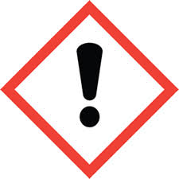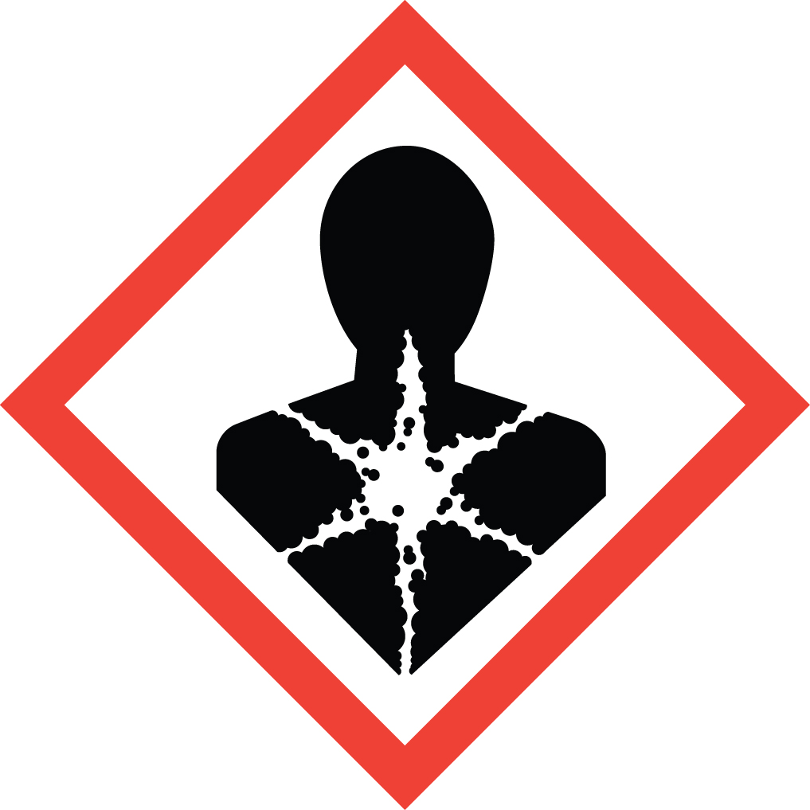
Precautionary Statements:
Keep container tightly closed
Do not handle until all safety precautions are read and understood
Wear protective gloves/eye protection/face protection/protective clothing
Avoid breathing dust/fumes/gas/mist/vapor/spray
Do not drink, smoke, eat – when using this product
Wash hands thoroughly after handling
Avoid release into environment
If on skin – remove contaminated clotihing immediately, wash with water
If in eyes – rinse cautiously with water – 15 minutes. Remove contact lenses
If skin irritation occurs – get medical attention
Dispose of contents / container in accordance with state/local/federal regulations
Women of childbearing potential should avoid occupational exposure

Hazards not otherwise classified or covered by GHS: None

SECTION 3: COMPOSITION/INFORMATION ON INGREDIENTS

INGREDIENT: CAS NO. % WT Hazards

Vitamin A Acetate 127-47-9 <6%
Vitamin K MSBC 130-37-0 <6%
Citric Acid 77-92-9 <17%
Ethoxyquin 91-53-2 <1%
Potassium Chloride 7747-40-7 <35%

SECTION 3 NOTES: All other ingredients are non-hazardous

SECTION 4: FIRST AID MEASURES

EYES: Flush for 15 minutes with water. Seek medical advice

SKIN: Wash thoroughly with soap and water.R emove and launder contaminated clothing before reuse. If irritation develops, seek medical advice

EYES: Immediately rinse with running water for minimum 15 minutes. Seek medical atttention

INGESTION: Do not induce vomiting unless directed by medical professional. Never give fluids or induce vomiting if victim is unconscious or having convulsions. Seek medical advice

INHALATION: Remove victim to fresh air. Aid breathing if necessary. Seek medical advice

Most important effects both acute and chronic: None known

Indication of immediate medical attention and special treatment needed: None known

Symptoms and Effects: this mixture has not been tested as a whole. Important symptons are listed in sections 2 and 11. Effects and symptoms for exposure to individual components reported are listed as:

Vitamin A Acetate: early signs of chronic Vitamin A intoxication include fatigue, irratibility, vomiting, loss of appetite, headache, vertigo, psychiatric changes mimicking severe depression or schizophrenia, anorexia, nausea, mild fever, dermatitis. Chronic intoxication may lead to fibrosis and cirrhosis of the liver, enlarged liver, spleen, jaundice, urinary complaints, anemia, leukopenia, and thrombocytopenia have been reported.

Vitamin K MSBC: irritant to skin and mucous membranes

Citric Acid: generally considered innocuous, though hypocalcemic effects are reported from transfusion of citrated blood. Frequent or excessive intake may cause erosion of teeth and local mucous membrane irritation.

Ethoxyquin: animal studies indicate chronic exposure by ingestion causes weight loss, vomiting, and adverse kidney and thyroid function. .

Potassium chloride: symptoms of acute poisoning are usually mild, provided renal function is adequate. Large single oral dosages usually induce vomiting, and normally renal function is adequate to rapidly excrete. Initial signs of poisoning – nausea, vomiting, diarrhea.

SECTION 5: FIRE-FIGHTING MEASURES

SUITABLE EXTINGUISHING MEDIA: Water, Dry Powder, Foam, Carbon Dioxide (dependent on surrounding environment) (DO NOT USE WATER JET)

SPECIAL FIRE FIGHTING PROCEDURES: Wear self contained breathing apparatus for fire fighting if necessary.

UNUSUAL FIRE AND EXPLOSION HAZARDS: May emit fumes of carbon oxides and nitrogen oxides.

HAZARDOUS DECOMPOSITION PRODUCTS: Not Known

SECTION 6: ACCIDENTAL RELEASE MEASURES

ACCIDENTAL RELEASE MEASURES: Notify management of material spills. Use personal protection equipment during cleanup – avoid vapor, gas, mist; ensure adequate ventelation, use exhaust to control mist, vapor. See section 8 for PPE required.

CONTAINMENT AND CLEANUP OF SPILLS: prevent further leakage; don’t let product enter drains; pickup and dispose of waste without creating excess dust. Keep in suitable containers for disposal. See Section 13 for disposal.

SECTION 7: HANDLING AND STORAGE

HANDLING: Avoid contact with eyes. Use suitable engineering controls for dust generation or wear suitbale respiratory protection if engineering controls are unsufficient. Practice good industrial hygene when handling this product. Avoid inhaling dust and vapor/mist when handling. See Section 2 for precautions.

STORAGE: Store in a cool dry place away from sources of high heat. Avoid dust when cleaning up; avoid drains. Keep in suitable closed container for disposal. Keep away from children, pets, and unauthorized handling. See disposal section 13

INCOMPATABILITIES: Oxidizers

SECTION 8: EXPOSURE CONTROLS/PERSONAL PROTECTION

EXPOSURE CONTROLS: Handle in accordance with GMP and safety practice. Mixture contains no substances with occupational exposure limits.

RESPIRATORY PROTECTION: A NIOSH-approved respirator for dust, if needed.

EYE PROTECTION: Recommended NIOSH approved safety glasses

SKIN PROTECTION: Recommended Gloves. Avoid skin contact when removing gloves. Dispose of contaminated gloves in accordance with good hygene and regulatory requirements. Wash and dry hands after use.

OTHER PROTECTIVE CLOTHING OR EQUIPMENT: Suitable for work surroundings

WORK HYGIENIC PRACTICES: Wash hands before eating or smoking; do not eat or drink while handling product.

SECTION 8 NOTES: Precautions such as the following should be observed: dust masks or respirators and protective clothing would be worn; dust arresting equipment and adequate ventilation should be utilized; personal hygiene should be observed; shower before eating or leaving work site; be alert for signs of allergic reactions – Seek medical treatment if such reactions are suspected.

SECTION 9: PHYSICAL AND CHEMICAL PROPERTIES

APPEARANCE: Yellow/White fine granular

ODOR: None

PHYSICAL STATE: Solid

pH AS SUPPLIED: <7 when dissolved in water

BOILING POINT: No data available

MELTING POINT: No data available

FREEZING POINT: No data available

FLASH POINT: No data available

VAPOR PRESSURE (mmHg): No data available

VAPOR DENSITY (AIR = 1): No data available

SPECIFIC GRAVITY (H2O = 1): No data available

EVAPORATION RATE: Not applicable

SOLUBILITY IN WATER: Soluble

PERCENT VOLATILE: No data available

VOLATILE ORGANIC COMPOUNDS (VOC): No data available

MOLECULAR WEIGHT: Not Applicable

VISCOSITY: No data available

FLAMMABILITY:
UPPER FLAMMABILITY LIMIT: No data available
LOWER FLAMMABILITY LIMIT: No data available

RELATIVE DENSITY: No data available

PARTITION COEFFICIENT: No data available
n-octanol/water

AUTO-IGNITION TEMPERATURE: No data available

DECOMPOSITION TEMPERATURE: No data available

VISCOSITY: No data available

SECTION 10: STABILITY AND REACTIVITY

REACTIVITY: No data available

STABILITY: Stable under recommended storage conditions

INCOMPATIBILITY (MATERIAL TO AVOID): Strong oxidizing agents; reactive metals

CONDITIONS TO AVOID: solutions of citric acid – if in contact with reactive metals like iron, zinc, or aluminum, form hydrogen gas, which can be explosive.

HAZARDOUS DECOMPOSITION OR BY-PRODUCTS: No data available

SECTION 11: TOXICOLOGICAL INFORMATION

ACUTE TOXICITY: See Section 4

SKIN IRRITATION / CORROSION: See Section 4

EYE IRRITATION / DAMAGE: See Section 4

RESPIRATORY OR SKIN SENSITISATION: No data available

CARCINOGENICITY:
IARC: No component of this product present at levels greater than or equal to 0.1% is identified as probable, possible or confirmed human carcinogen by IARC.

ACGIH: No component of this product present at levels greater than or equal to 0.1% is identified as a carcinogen or potential carcinogen by ACGIH.

NTP: No component of this product present at levels greater than or equal to 0.1% is identified as a known or anticipated carcinogen by NTP.

OSHA: No component of this product present at levels greater than or equal to 0.1% is identified as a carcinogen or potential carcinogen by OSHA.

GERM CELL MUTAGENICITY: No data available

REPRODUCTIVE TOXICITY: No data available

SPECIFIC TARGET ORGAN:
Single Exposure: Inhalation – may cause respiratory irritation

Repeated Exposure: No data available

ACUTE TOXICITY - this mixture has not been tested for toxicity or health effects as a whole. Information on individual elements is presented below:
Acute Toxicity – no data available
Skin corrosion / irritation – citric acid tested for mild skin irritation
Serious eye damage / irritation – citric acid tested as an eye irritant
Respiratory / skin sensitizing – ethoxyquin may caus allergic skin reaction
Germ cell mutagenicity – no data available
Reproductive / developmental toxicity – Vitamin A actate is a presumed reproductive and developmental toxicant (cat 1b); damageetus possible; developmental abnormalities observed in respiratory system, somatic cell changes; abnormalities of central nervous system (eyes, ears), cariofacial – nose, tongue.
Specific organ toxicity – no data available for single or repeat exposure

SECTION 12: ECOLOGICAL INFORMATION

ECOTOXICITY: this product has not been tested for toxicity or health effects as a whole. Information on individual elements is presented below:
Ethpxyquin – toxicity to daphnia an dother aquatic invertebrates

PERSISTANCE & DEGRADABILITY: No data available

BIOACCUMULATIVE POTENTIAL: No data available

MOBILITY IN SOIL: No data available

OTHER ADVERSE EFFECTS: environmental hazard cannot be precluded in event of unprofessional handling or disposal.

SECTION 13: DISPOSAL CONSIDERATIONS

WASTE DISPOSAL METHOD: Product spills should be swept up for disposal, avoid breathing dust. Follow all federal, state and local regulations for disposal. Surplus / waste should be disposed of by licensed disposal company. Contaminated packaging should be disposed of as unused / waste product.

SECTION 14: TRANSPORT INFORMATION

DOT (US): Non-hazardous goods

IMDG: Non-hazardous goods

IATA: Non-hazardous goods

SECTION 15: REGULATORY INFORMATION

U.S. FEDERAL REGULATIONS:

SARA TITLE III (SUPERFUND AMENDMENTS AND REAUTHORIZATION ACT):

302 REPORTABLE INGREDIENTS: This material does not contain any chemicals subject to reporting requirements of SARA Title III, Section 302.

311/312 HAZARD CATEGORIES: This material does not contain any chemicals with known CAS numbers that exceed reporting levels established by SARA Title III, Section 311/312.

313 REPORTABLE INGREDIENTS: This material does not contain any chemicals with known CAS numbers that exceed reporting levels established by SARA Title III, Section 313.

STATE REGULATIONS:

Right to Know Components – NJ/PA: Niacinamide, Vitamin K MSBC, Pydoxine HCl, Potassium chloride, amorphous silicon dioxide, folic acid, Vitamin D3, D-Calcium pantothenate, sodium chloride, biotin, riboflavin, thiamin, citric acid, ascorbic acid, vitamin A acetate, ethoxyquin - are listed on the Pennsylvania and New Jersey right to know components lists.

California Prop. 65 Components: This material does not contain any chemicals on the Califiornia Prop. 65 list

Massachusetts Right to Know Components: silicon dioxide amorphous

SECTION 16: OTHER INFORMATION

HAZARD STATEMENTS:
H315: Causes skin irritation
H319: Causes serious eye irritation
H401: Toxic to aquatic life
H3602D: may damage unborn child
H317: may cause allergic skin reaction

OTHER INFORMATION:
Label for animal feed use only. Ingredients contained in this product are approved for use in a regulation
of the Food and Drug Administration (21 CFR 172, 182, 184 and 582).

Certain components of animal feeds include medicated premixes; possess properties that may be potential health hazard or a source of personal discomfort to certain individuals who are exposed to them. Human exposure should therefore, be minimized by observing the general industry standards for occupational health and safety.

DISCLAIMER: The information contained herein, to the best of our knowledge, is true and accurate. Any recommendations or suggestions are made without warranty or guarantee, since the conditions of use are beyond our control. Nothing contained herein shall be construed to imply the non-existence of any relevant patents or to constitute a permission, inducement or recommendation to practice any invention without authority from the owner of the patent.

PREPARATION INFORMATION: Prepared by: Dana Partridge
Previous Rev Date: N/A
Current Rev Date: 8/4/2017

