Stenner Water Meter

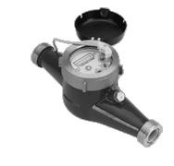

Comes in ¾, 1’, 1.5” and 2” models that can be either 1, 2 or 4 gallon pluse

